EI1EL2 - Audio amplifier design project
Dr Ian Phillips, December 2025

Introduction
This document contains the briefing information for the audio amplifier design project. This document includes information on the objectives, required reading, schedule and assessment. It also includes some advice on how to complete a successful project.

Objectives and Learning Outcomes

LO2: Implement and report individual electronic engineering project work to a given specification from design through to build and test.

Plan the development of a simple prototype.

Use Proteus software to design and simulate a circuit and layout a PCB.

Demonstrate build and test skills for a simple circuit.

Understand the design and workings of an audio amplifier.

Write a concise but comprehensive design and test report (within a page limit).

Task
You are required to design an audio amplifier and speaker system that takes a signal from an MP3 player (or phone) and amplifies the input signal sufficiently to power a speaker.

Strong hint – setting up an Excel spreadsheet to do your calculations will help you with the calculations and manage any required changes in an efficient way, see Table 1 below.
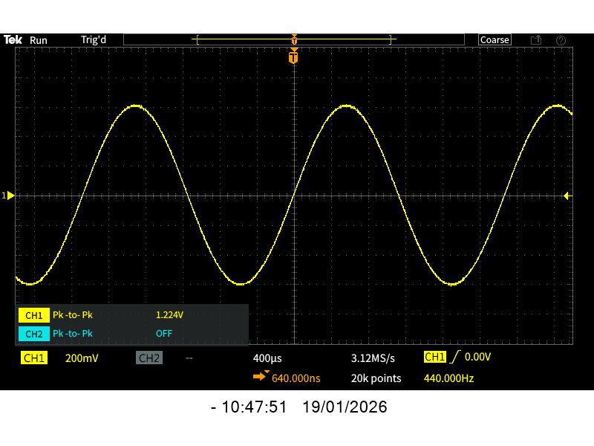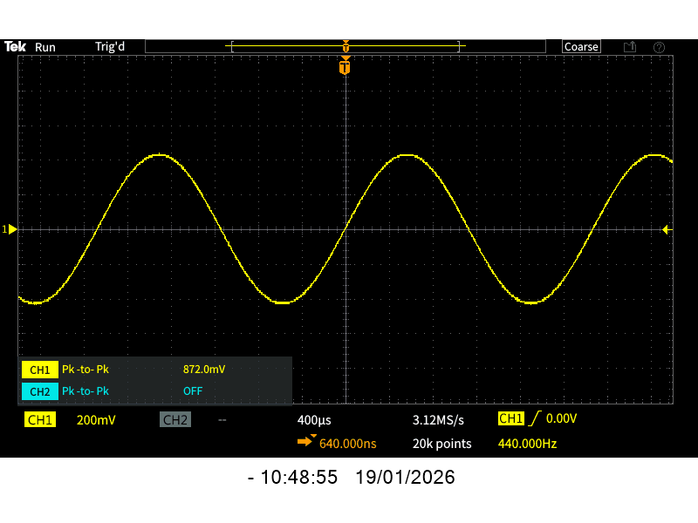

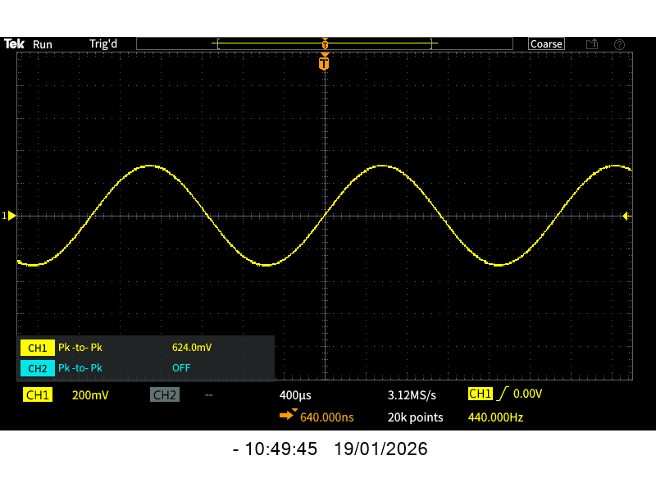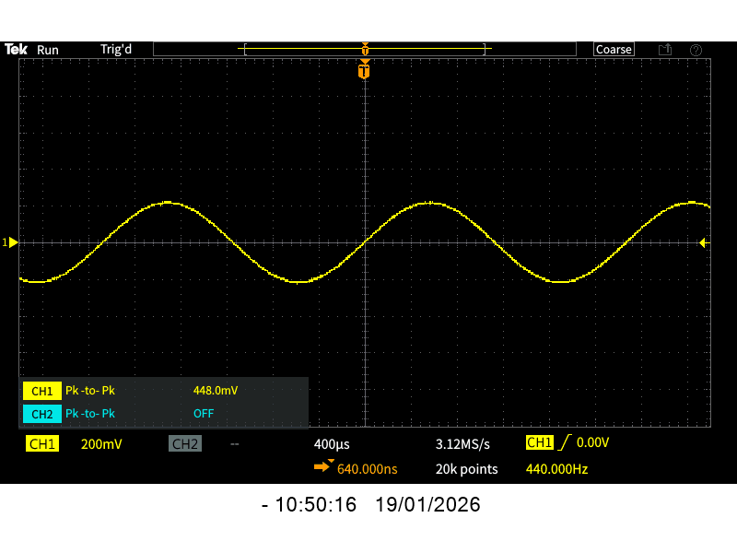

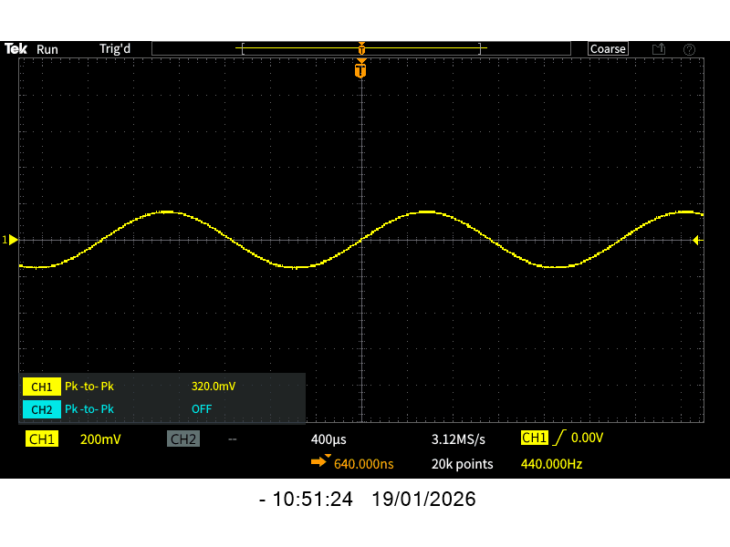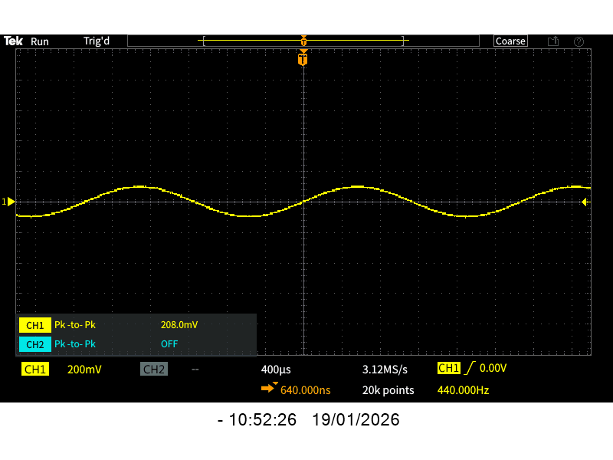
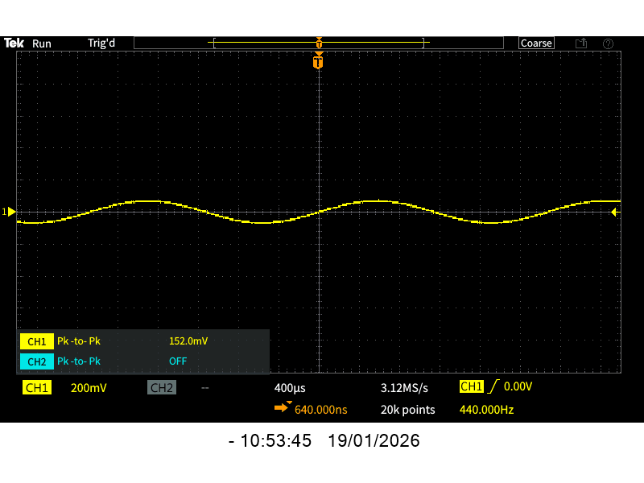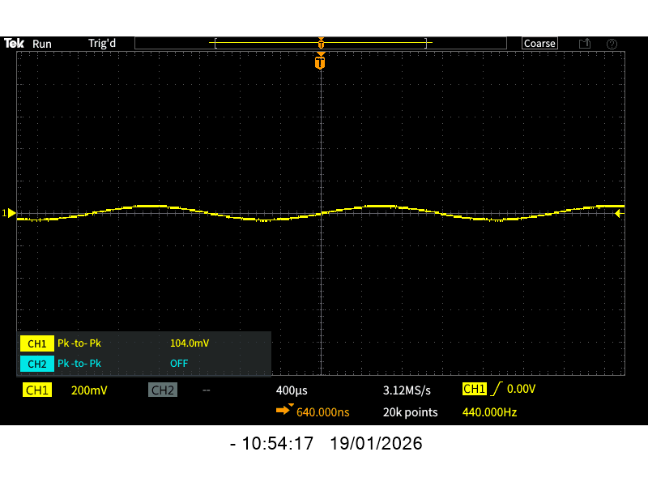

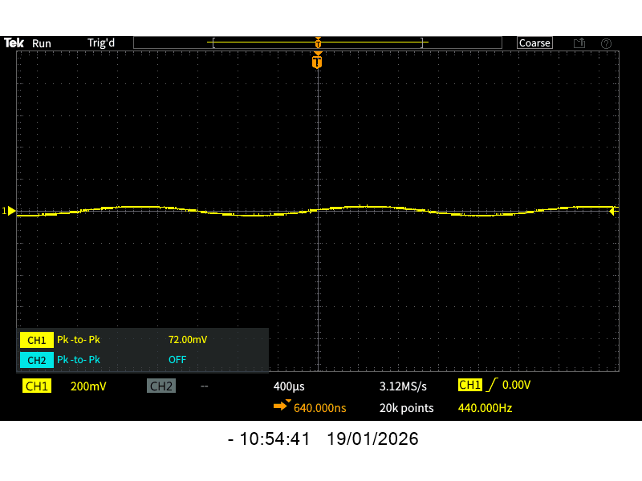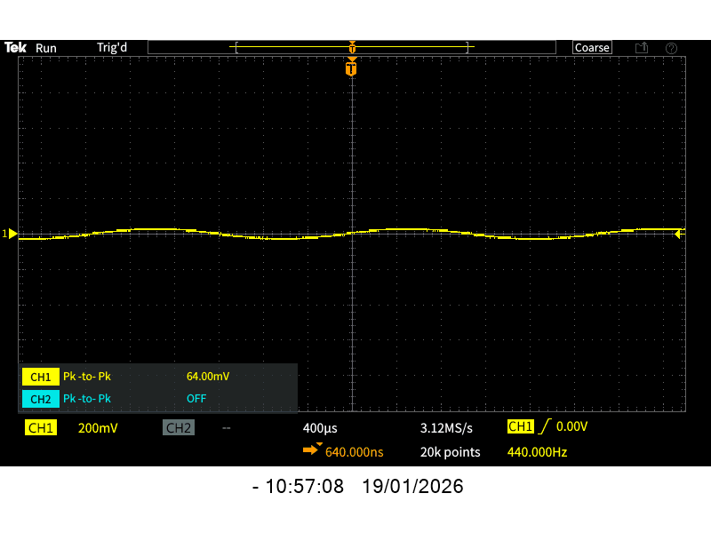

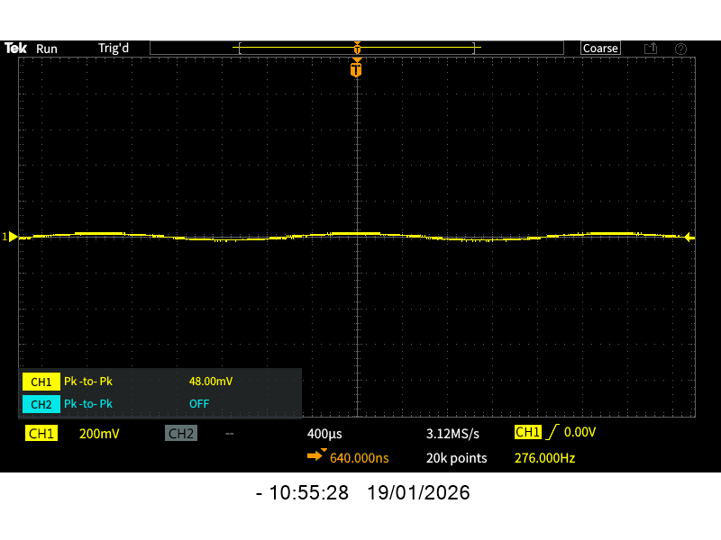
Mobile Phone Characterization
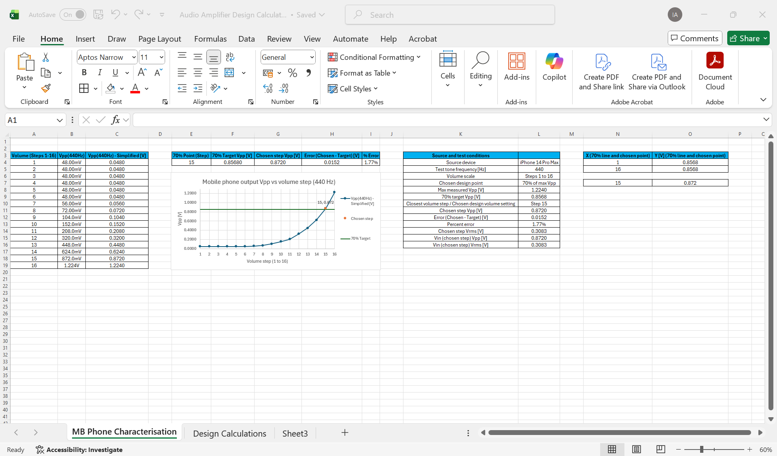

Mobile phone characterisation (input signal measurement)

Aim
To measure the peak-to-peak output voltage (Vpp) of the audio source device at 440 Hz across the available volume settings, then select a suitable design input level for the amplifier calculations.

Equipment and setup
Source device - iPhone 14 Pro Max
Test tone - 440 Hz sine wave
Measurement instrument - oscilloscope (Vpp measurement)
Volume scale - 16 discrete volume steps (Steps 1 to 16)

Method
1. A 440 Hz sine wave was played from the phone.
2. The phone output was connected to the oscilloscope input and the output amplitude was measured as Vpp for each of the 16 volume steps.
3. The measured Vpp values were recorded in a table in Excel. The raw measurements were originally noted in mV for most steps and one value in V at the highest step.

Data processing and conversion in Excel
To keep the sheet fully automatic, a conversion column was created to express all measurements in volts. A formula was used so that if any measurement is changed, all dependent values update automatically. The converted column (Vpp in V) is used for all further calculations and graph plotting.

Selecting a design point (70% of maximum)
To define a consistent design input level, a target value equal to 70% of the maximum measured phone output was calculated.

Maximum measured Vpp = 1.2240 V
70% target Vpp = 0.7 × 1.2240 = 0.8568 V

The measured volume step closest to the 70% target was then selected.

Closest volume step = Step 15
Chosen step Vpp = 0.8720 V

A small difference exists because the phone volume settings are discrete rather than continuous.

Error (Chosen - Target) = 0.8720 - 0.8568 = 0.0152 V
Percent error = (0.0152 / 0.8568) × 100% = 1.77%

For later gain and power calculations, the RMS input voltage at the chosen step was also calculated from the measured Vpp.

Vrms = Vpp / (2√2)
Chosen step Vrms = 0.8720 / (2√2) = 0.3083 V

Graph and presentation
A graph of Vpp (V) vs volume step was produced in Excel using the converted voltage values. The following were included to make the chosen operating point clear.

- A horizontal 70% target reference line at 0.8568 V
- A labelled marker at the chosen design point (Step 15, 0.872 V)

This graph and the summary table will be inserted into the report as evidence of the input signal level used for the amplifier design.

Notes and challenges
- The phone volume steps are not linear, so voltage increases slowly at low steps and rises sharply at higher steps.
- Because of discrete volume steps, the 70% point cannot be matched exactly, so the closest step was chosen and the resulting error was quantified.
- Excel formulas were used throughout to ensure the sheet remains robust and updates automatically if any measurements are revised.

What happens next
The chosen input level (Step 15) will be used as the amplifier input for the design stage. The next step is to move to the Design Calculations sheet to determine the required amplifier voltage gain to meet the output specification, then select component values for the gain stage and filter stages.

Table 1. Example Excel calculation. Double click and save as a separate file
You will have been given individual values for either a lower or upper cut-off frequency, and are free to choose the other cut-off frequency from within the ranges below:
- Lower Frequency cut-off range = 5 to 15 Hz
- Upper Frequency cut-off range = 22 to 46 kHz

Each student has specific values / components to work with, and these will be shown on Blackboard. If you find that your particular combination does not work speak to Ian for permission to change them.

Your device should be able to run from a 12V DC power supply or 9V PP3 battery. The amplifier, power source and speaker must be securely mounted on a base plate. You must include an on/off switch, power indicator LED, use a TL071 amplifier to add together your two stereo signals and act as an active bandpass filter and an OPA551 amplifier to drive the speaker.

The University will provide one set of on-board electronic components and the base mount free of charge (excluding the power supply). If you want to spend some of your own money on e.g. buying a speaker on an enclosure for the electronics that is ok, however we encourage you to think creatively and reuse materials from other sources to reduce wastage and improve performance.

You will keep the device at the end of the project once it has been marked so it is worth investing some time and effort in the project.

My Understanding
Phone L + R (Stereo)?
↓
TL071 – Signal Amplifer (Brain/Tone Control/steering wheel)
(summing + band-pass + gain)
↓
OPA551 – Power Amplifier (Muscle/engine)
(current drive)
↓
Speaker (Mono)

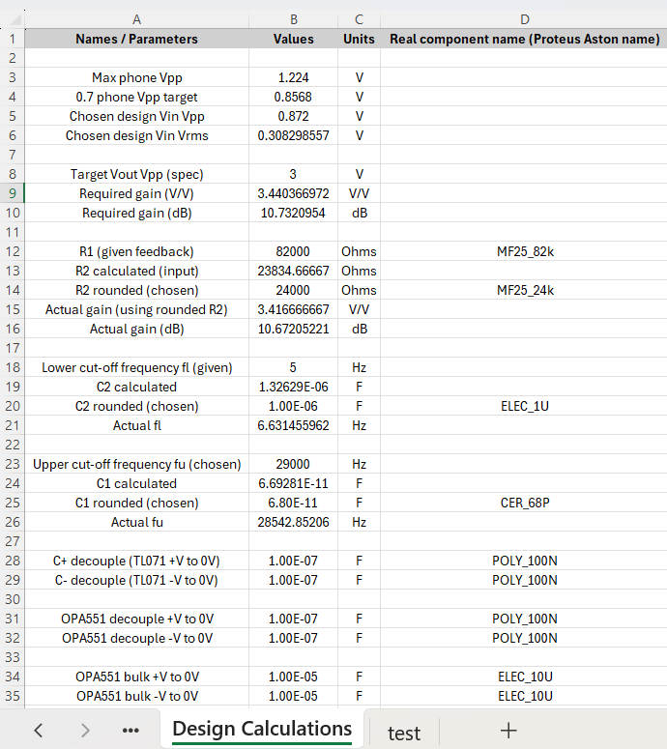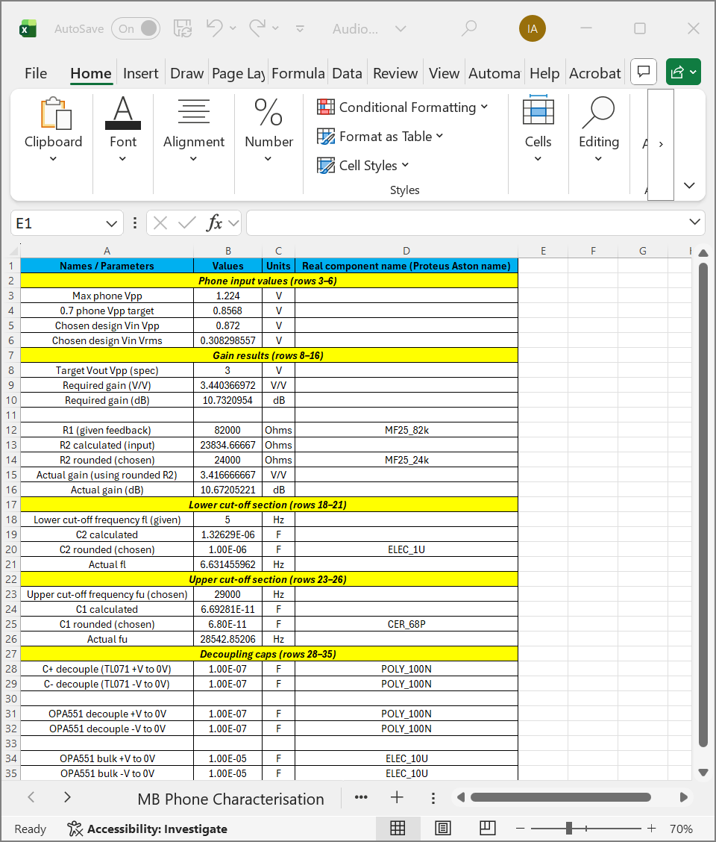

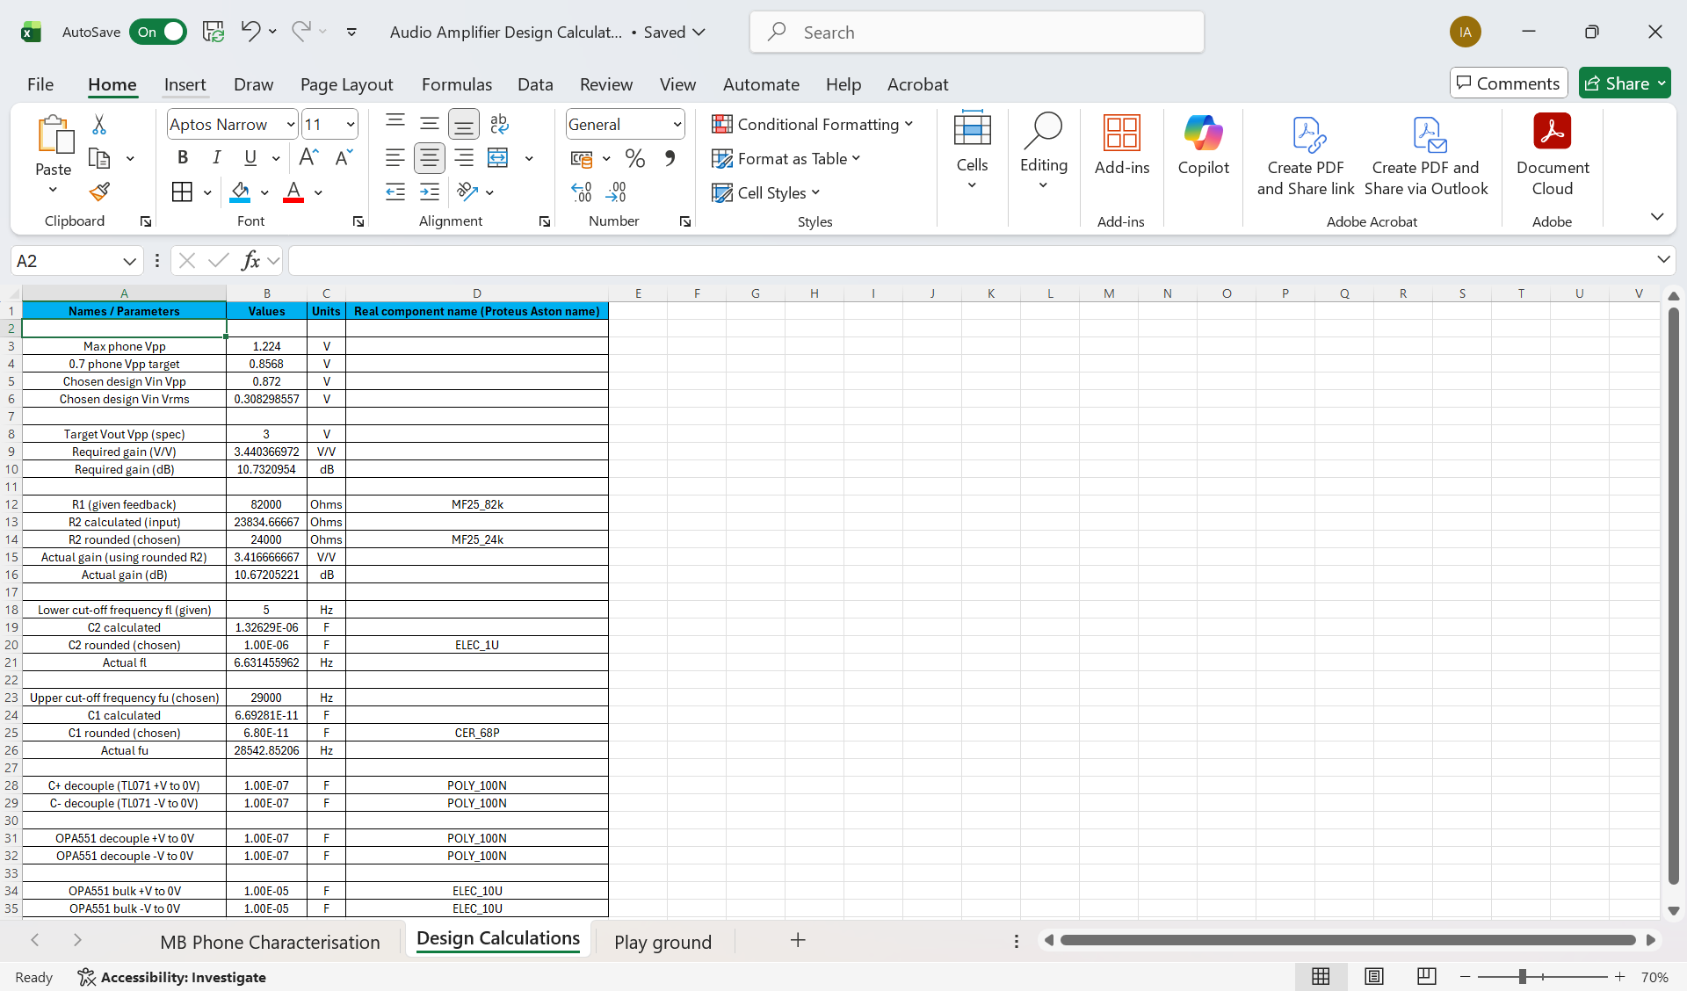

Design calculations and component selection
The amplifier input level was taken from the mobile phone characterisation. The maximum measured phone output was 1.224 Vpp at 440 Hz, and the design point was set at 70% of maximum, giving a target of 0.8568 Vpp. The closest available discrete phone volume step was selected as Step 15, giving Vin = 0.872 Vpp. The corresponding RMS value used for gain checks was calculated using:
Vrms = Vpp / (2√2)
This gave Vin,rms = 0.3083 V.
Target gain
The output specification required Vout = 3.0 Vpp. Therefore the required voltage gain was calculated as:
Gain (V/V) = Vout,Vpp / Vin,Vpp = 3.0 / 0.872 = 3.4404 V/V
Gain in decibels was calculated using:
Gain (dB) = 20 log10(Gain)
This gave a required gain of 10.732 dB.
First stage resistor selection (TL071 gain stage)
The feedback resistor was given as R1 = 82 kΩ and was selected directly from the Aston stock list as MF25_82k
N205_Stock_2019-11-27
.
For a non inverting style gain relation (as used in the module guidance), the required input resistor was calculated from:
R2 = R1 / (Gain − 1)
This gave R2,calc = 23,834.67 Ω. The closest available stock value was selected as:
R2 = 24 kΩ, stock name MF25_24k
N205_Stock_2019-11-27
.
Using the rounded resistor value, the actual gain became:
Actual gain = 1 + (R1 / R2) = 1 + (82000 / 24000) = 3.4167 V/V
Actual gain(dB) = 20 log10(3.4167) = 10.672 dB
This remains close to the required 10.732 dB and is within normal tolerance expectations for stocked component rounding.
Lower cut-off frequency selection (high pass behaviour)
The lower cut-off frequency was given as fl = 5 Hz. The capacitor for the lower cut-off was calculated using the standard first order corner frequency relation:
fl = 1 / (2π R C) → C = 1 / (2π R fl)
With R = R2 = 24 kΩ, the calculated value was C2,calc = 1.326 × 10⁻⁶ F. A stocked electrolytic capacitor was then selected as:
C2 = 1 µF, stock name ELEC_1U
N205_Stock_2019-11-27
.
The resulting actual lower cut-off was recalculated using:
Actual fl = 1 / (2π R2 C2)
This gave Actual fl ≈ 6.63 Hz.
Upper cut-off frequency selection (high frequency roll off)
The upper cut-off frequency was chosen within the specified allowable range (22 kHz to 46 kHz) from the project guidance
Audio amplifier project briefing
. A practical target of fu = 29,000 Hz was selected to sit comfortably above the audio band while remaining inside the allowed limits.
The capacitor required to set this upper cut-off with R1 = 82 kΩ was calculated using:
fu = 1 / (2π R C) → C = 1 / (2π R fu)
This gave C1,calc = 6.693 × 10⁻¹¹ F. The closest stocked ceramic capacitor was selected as:
C1 = 68 pF, stock name CER_68P
N205_Stock_2019-11-27
.
The resulting actual upper cut-off was recalculated using:
Actual fu = 1 / (2π R1 C1)
This gave Actual fu ≈ 28.54 kHz. The difference between chosen fu and actual fu occurs because the calculated capacitor value must be rounded to an available stocked component value.
Power supply decoupling components (TL071 and OPA551)
Decoupling capacitors were included to stabilise both amplifier ICs and reduce supply noise coupling into the signal path. The project guidance specifies 100 nF capacitors from each supply pin to 0 V. These were implemented as:
- TL071 +V to 0 V: 100 nF, stock name POLY_100N
N205_Stock_2019-11-27
- TL071 −V to 0 V: 100 nF, stock name POLY_100N
N205_Stock_2019-11-27
- OPA551 +V to 0 V: 100 nF, stock name POLY_100N
N205_Stock_2019-11-27
- OPA551 −V to 0 V: 100 nF, stock name POLY_100N
N205_Stock_2019-11-27
Optional bulk decoupling was also included for the power stage to support current transients, using:
- OPA551 bulk +V to 0 V: 10 µF, stock name ELEC_10U
N205_Stock_2019-11-27
- OPA551 bulk −V to 0 V: 10 µF, stock name ELEC_10U
N205_Stock_2019-11-27
These parts were selected directly from the Aston stock list to ensure the same values can be used in simulation, breadboard build, and PCB build.
N205_Stock_2019-11-27

What the next section is tomorrow
Proteus simulation plan
This is what to do next in a clean order:
- Place parts using the stock search names
- TL071: TL071CP
- OPA551: OPA551PA
N205_Stock_2019-11-27
(Also make sure the opa551.mod model file is available for Proteus as noted in the stock document
N205_Stock_2019-11-27
)
- Wire the stage 1 network using calculated values
- R1 = 82k, R2 = 24k, C1 = 68p, C2 = 1u, plus your chosen input network from the brief
- Add power decoupling physically close to the IC power pins
- POLY_100N on each supply pin to 0 V
- ELEC_10U bulk near the OPA551 supply pins
N205_Stock_2019-11-27
- Run two key simulations
- AC sweep (frequency response) to confirm:
  - lower cut-off near 6 to 7 Hz
  - upper cut-off near 28 to 29 kHz
  - midband gain near 10.7 dB
- Transient at 440 Hz using Vin around 0.872 Vpp to confirm output around 3 Vpp without clipping
- Capture screenshots and export plots
- One frequency response plot with labelled cut-offs
- One transient plot showing Vin and Vout Vpp

Design Calculations (gain and filter design using measured phone input)
Purpose
The aim of this stage was to convert the measured phone output level into a complete amplifier design set, including:
- required voltage gain to meet the output specification
- resistor values for the gain stage (including rounding to real stock parts)
- lower and upper cut-off filter capacitor values (including rounding to real stock parts)
- practical decoupling capacitor choices for stable op-amp operation in simulation and hardware
All calculations were built in Excel so that any future change to input measurements or design targets automatically updates every dependent value.

Step 1: Importing the measured input level from Mobile phone characterisation
From the phone measurement stage, the chosen operating point was:
- Chosen design input Vpp = 0.872 V (Step 15)
- Chosen design input Vrms = 0.3083 V
These values were used as the amplifier input reference for the design stage. In Excel, linking was used so the design sheet stays connected to the characterisation sheet. This means if the chosen step changes in future, the design calculations update automatically.

Step 2: Required output and gain calculation
The output specification used was:
- Target Vout Vpp (spec) = 3 V
The required voltage gain was calculated as:
- Gain (V/V) = Vout(Vpp) / Vin(Vpp)
= 3 / 0.872
= 3.4404 V/V
This was also converted into decibels:
- Gain (dB) = 20 log10(Gain V/V)
= 20 log10(3.4404)
= 10.7321 dB
This defined the target gain for the amplifier stage.

Step 3: Gain stage resistor design (R1 given, R2 calculated and rounded)
The gain stage uses a standard non-inverting configuration where:
- Gain (V/V) = 1 + (R1 / R2)
A feedback resistor was given:
- R1 = 82 kΩ (given)
Rearranging to calculate R2:
- R2 = R1 / (Gain − 1)
= 82000 / (3.4404 − 1)
= 23834.67 Ω
Because real components must match the Aston/Proteus stock values, R2 was rounded to the nearest available value:
- R2 chosen = 24 kΩ (MF25_24k)
The actual achieved gain using the rounded resistor was recalculated:
- Actual Gain (V/V) = 1 + (R1 / R2chosen)
= 1 + (82000 / 24000)
= 3.4167 V/V
- Actual Gain (dB) = 20 log10(3.4167)
= 10.6721 dB
This confirms the final gain is very close to the target gain, and it uses a real available resistor.

Step 4: Lower cut-off frequency design (fl, calculate C2, choose a real capacitor)
The lower cut-off frequency was given as:
- fl = 5 Hz
Using the high-pass relationship provided in the project intro, C2 was calculated in Excel from the design equation (linked to the relevant resistor value in the sheet).
- C2 calculated = 1.32629 × 10⁻⁶ F
This value was then rounded to a real capacitor value available in stock:
- C2 chosen = 1 µF
- Stock component name used: ELEC_1U
After rounding, the actual lower cut-off was recalculated:
- Actual fl = 6.631 Hz
This is still close to the intended low-frequency performance and is acceptable because the design is limited by available stock capacitor values.

Step 5: Upper cut-off frequency design (fu chosen, calculate C1, choose a real capacitor)
The upper cut-off is not fixed in the brief, but must be within the allowed range. A chosen value of:
- fu chosen = 29 kHz
was selected, then C1 was calculated using the design equation in Excel:
- C1 calculated = 6.69281 × 10⁻¹¹ F
A real capacitor value was then chosen from stock:
- C1 chosen = 68 pF
- Stock component name used: CER_68P
Because of rounding, the achieved upper cut-off frequency becomes:
- Actual fu = 28.54 kHz
This is still within the intended band and meets the requirement of keeping the cut-off above the audio range while remaining realistic with stock component options.

Step 6: Decoupling capacitors for stability (TL071 and OPA551)
Decoupling capacitors were included as practical design choices to improve stability and reduce noise on power pins. These do not come from the filter equations, they are standard good practice for op-amp circuits and are required for reliable simulation and real hardware.
For both TL071 and OPA551:
- 100 nF (0.1 µF) ceramic/film decoupling from each supply rail to 0 V was selected:
  - POLY_100N
Optional bulk decoupling was also included for the power stage:
- 10 µF electrolytic capacitors:
  - ELEC_10U
These help with sudden current demands and reduce supply ripple in the output stage.
Note: Whether both +V and -V parts are used depends on the final supply arrangement in Proteus. The sheet keeps both listed so the bill of materials can be quickly adapted once the supply configuration is finalised.

What I learned while building the Excel design sheet
This stage improved my Excel skills a lot because I stopped doing one-off calculations and instead built a fully linked calculation workflow:
- using formulas so every value updates automatically
- referencing cells across sheets to avoid retyping measurements
- recalculating “actual” values after rounding to real components
- keeping units separate from values so formulas stay clean
- organising the sheet into clear sections so it matches how the circuit is built in stages
This made the work more reliable and easier to explain, because every result can be traced to a formula rather than manual calculator steps.

Challenges and how they were solved
Challenge 1: Choosing real component values instead of ideal calculated values
Calculated resistor and capacitor values often do not exist exactly in stock. This was solved by:
- rounding to the nearest available Aston stock value
- then recalculating the “actual” gain or cut-off frequency so the impact is quantified
Challenge 2: Keeping the sheet readable while still fully automatic
Large formula-driven sheets can become messy. This was solved by:
- using section headers (phone input, gain, lower cut-off, upper cut-off, decoupling)
- keeping a consistent 4-column structure
- clearly labelling “given”, “calculated”, “rounded”, and “actual” rows
Challenge 3: Avoiding mistakes when updating values
When values are typed manually in many places it is easy to break consistency. This was solved by:
- linking key design inputs (Vin Vpp, Vrms) from the characterisation sheet
- using formulas for all calculated results so updates propagate correctly

What happens next (Proteus simulation plan)
The next stage is simulation in Proteus using the calculated and selected component values:
- build the schematic with TL071 gain stage and OPA551 output stage
- place the chosen resistors and capacitors using their Proteus Aston library names
- confirm:
  - gain matches the expected value
  - frequency response shows the intended lower and upper cut-offs
  - time-domain waveform is not clipping at the target output
- adjust only if simulation shows instability or incorrect gain response, then update the Excel sheet so the report stays consistent

Project Overview and Methodology
This project involved the design, simulation, and verification of a single-stage audio amplifier suitable for amplifying an audio signal from a mobile phone source to a level appropriate for further amplification or speaker driving. The work followed a structured engineering design process, beginning with input signal characterisation and planning, progressing through analytical design calculations, and concluding with circuit simulation and verification using Proteus software.

Project Planning and Organisation
At the start of the project, a Gantt chart was created to plan and manage the workload across the full project duration. The chart divided the project into clearly defined stages including input signal characterisation, design calculations, schematic design, simulation, analysis, and report writing. Task dependencies and expected completion dates were included to ensure steady progress and to reduce the risk of delays.
Alongside the Gantt chart, a parts list and status tracking system was maintained in Excel. This allowed components to be tracked against availability and ensured that selected resistor and capacitor values aligned with the Aston University component stock list. Status indicators were used to clearly show completed, in-progress, and pending tasks, helping to maintain clarity and organisation throughout the project.

Input Signal Characterisation
The input signal was based on a mobile phone audio output playing a 440 Hz sine wave. The peak-to-peak output voltage of the phone was measured across the available volume steps using an oscilloscope. These measurements were recorded in Excel and automatically converted into volts to maintain consistency and allow all dependent calculations to update dynamically.
To define a realistic and repeatable design point, 70% of the maximum measured phone output was selected. This approach ensured sufficient signal headroom while avoiding clipping at high volume settings. The volume step closest to this target value was chosen, and the corresponding RMS input voltage was calculated. This RMS value was then used as the input reference for all subsequent amplifier gain and power calculations.

Design Calculations and Excel Modelling
An Excel spreadsheet was used extensively to perform and manage all design calculations. This included voltage gain requirements, RMS conversions, frequency response estimation, and component selection. Using Excel ensured transparency, repeatability, and flexibility, allowing rapid adjustment of component values while preserving calculation accuracy.
The frequency response of the amplifier was also modelled in Excel using a logarithmic frequency sweep. The calculated gain in decibels was plotted against frequency to produce an expected band-pass response. This theoretical response provided a reference against which the Proteus simulation results could later be compared.

Circuit Design and Schematic Simulation
Based on the design calculations, an active amplifier and filter circuit was implemented in Proteus using a TL071 operational amplifier. The circuit was powered using a ±9 V dual supply to allow both the input and output signals to be centred about 0 V, which simplifies analysis and avoids distortion associated with single-supply operation at this stage.
The input signal was AC-coupled using a capacitor to block any DC component, while the feedback network consisting of resistors and capacitors defined the gain and frequency response of the amplifier. All component values used in the schematic matched those calculated in Excel and were chosen from standard values available within the Aston University component stock.

Simulation and Verification
Two main types of simulation were performed in Proteus: frequency-domain analysis and time-domain analysis.
A frequency response simulation was carried out using an AC sweep. The resulting plot demonstrated clear band-pass behaviour, with attenuation at low and high frequencies and a flat mid-band region. The simulated mid-band gain was approximately 10 to 11 dB, closely matching the value predicted by the Excel calculations. Minor deviations between theoretical and simulated results were expected due to the non-ideal characteristics of the TL071 op-amp model.
Time-domain (transient) simulations were also conducted using a sinusoidal input signal within the passband. The output waveform was a clean amplified sine wave with no visible clipping or distortion. This confirmed that the amplifier was operating within its linear region and that the selected gain and supply voltages were appropriate for the chosen input signal level.

Comparison Between Theory and Simulation
A direct comparison was made between the Excel-generated frequency response and the Proteus simulation results. Both showed a similar overall shape, mid-band gain, and cut-off behaviour. This agreement validated the design calculations and confirmed that the schematic implementation correctly translated the theoretical design into a practical circuit.
Such comparison demonstrates good engineering practice, as it shows consistency between analytical modelling and simulation-based verification.

Summary
The project successfully followed a complete engineering workflow from planning and signal characterisation through to design, simulation, and verification. Excel was used to manage calculations, data processing, and project tracking, while Proteus provided a realistic simulation environment to validate circuit behaviour. The results confirm that the designed amplifier meets the intended specifications and is suitable for further development, including single-supply biasing and physical implementation on a breadboard or PCB.

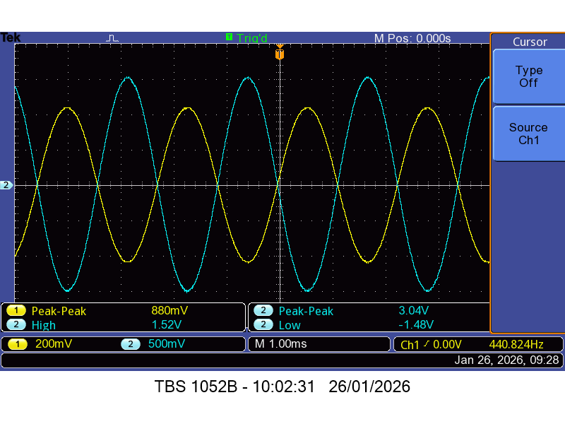

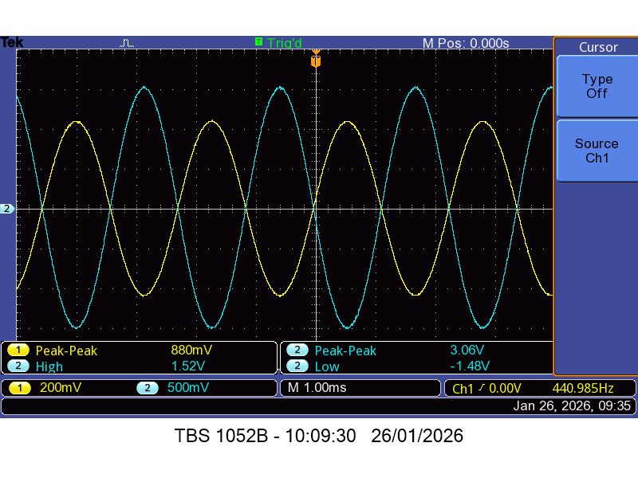

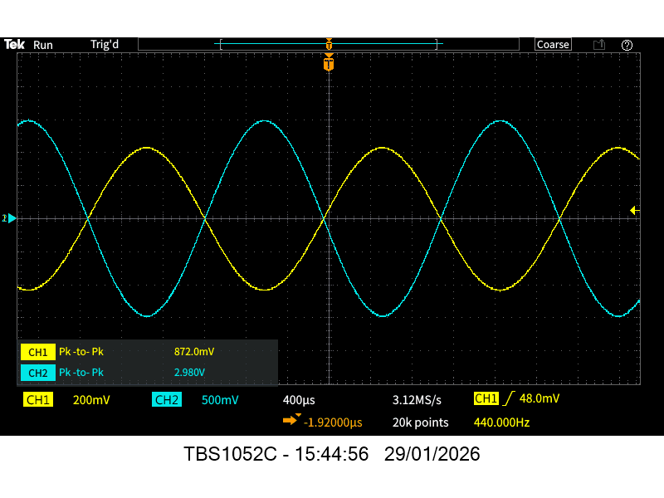
Dual supply at 440Hz
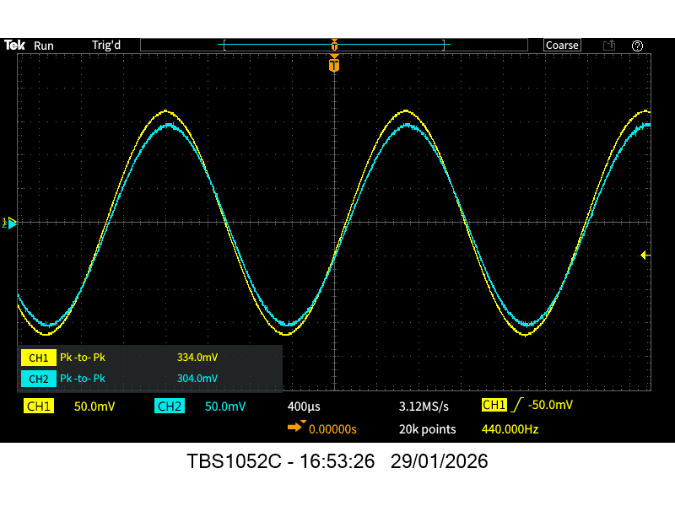
Single supply at 440hz

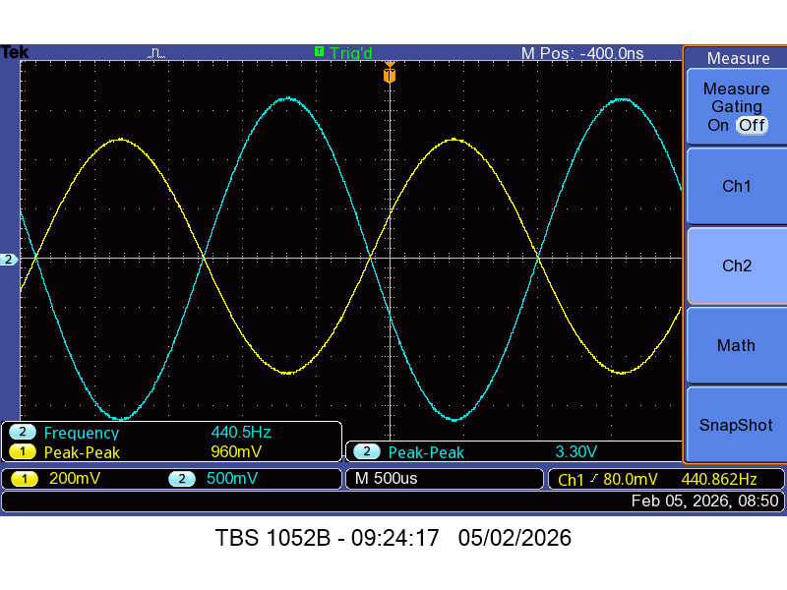
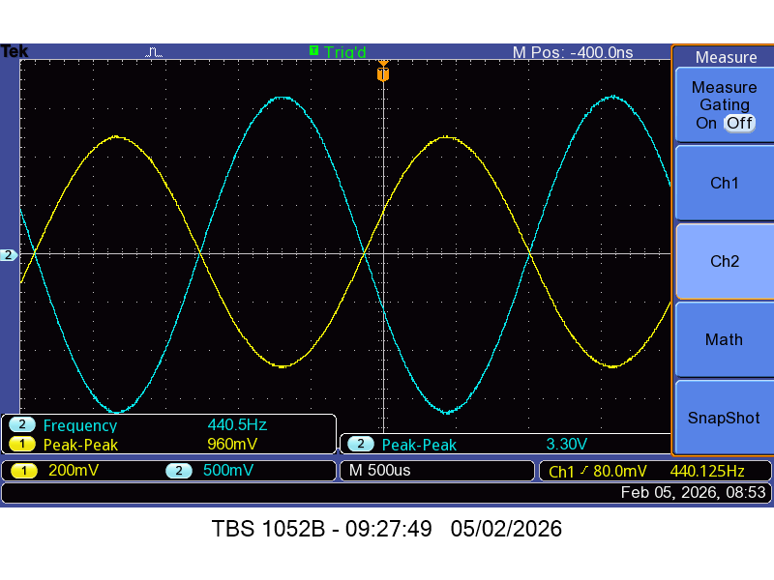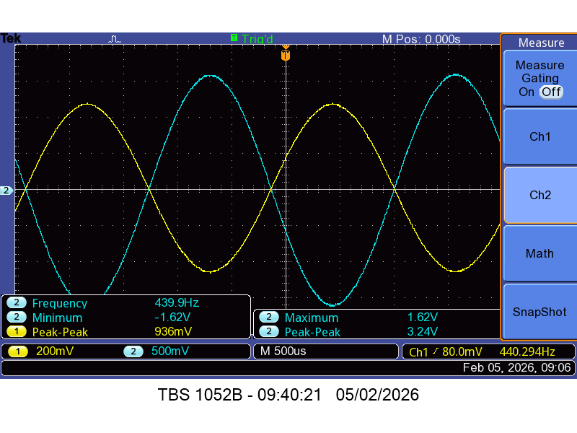
PCB Measurements
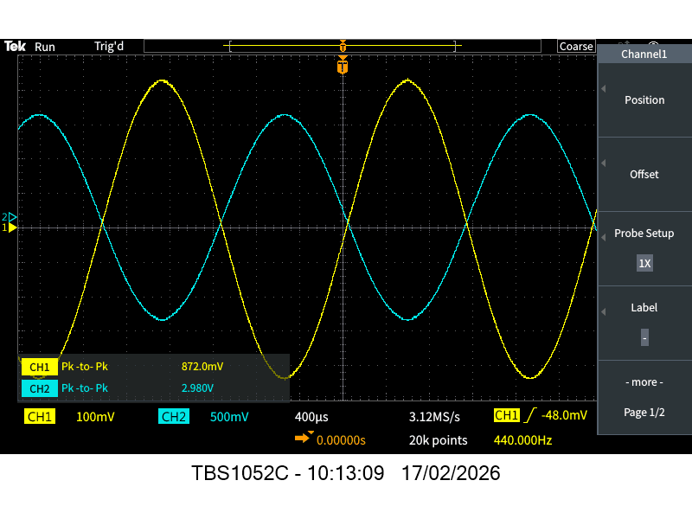
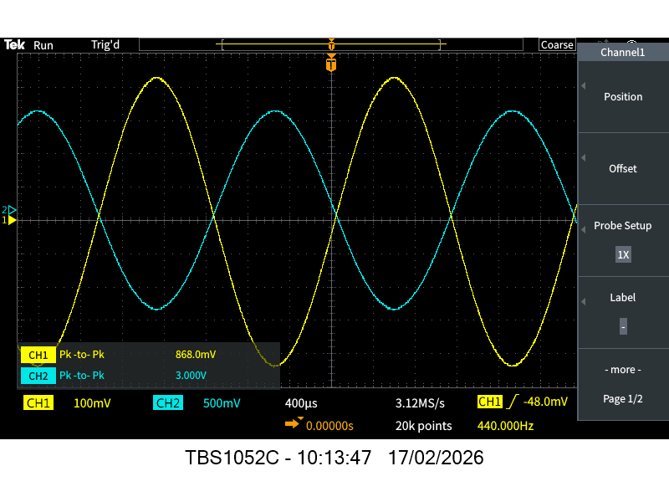
Pcb with both chips in
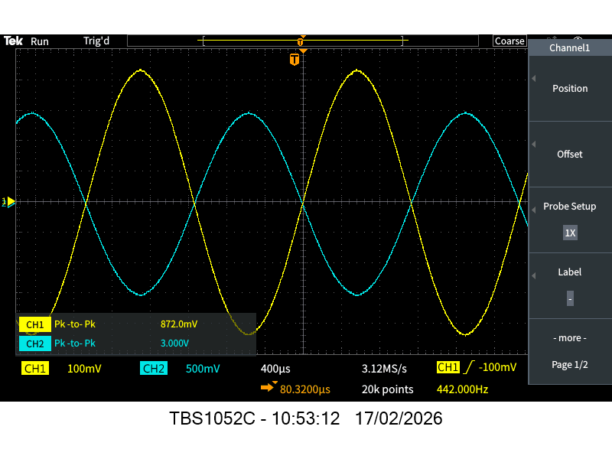
At lower cut – off – 6. 3hz
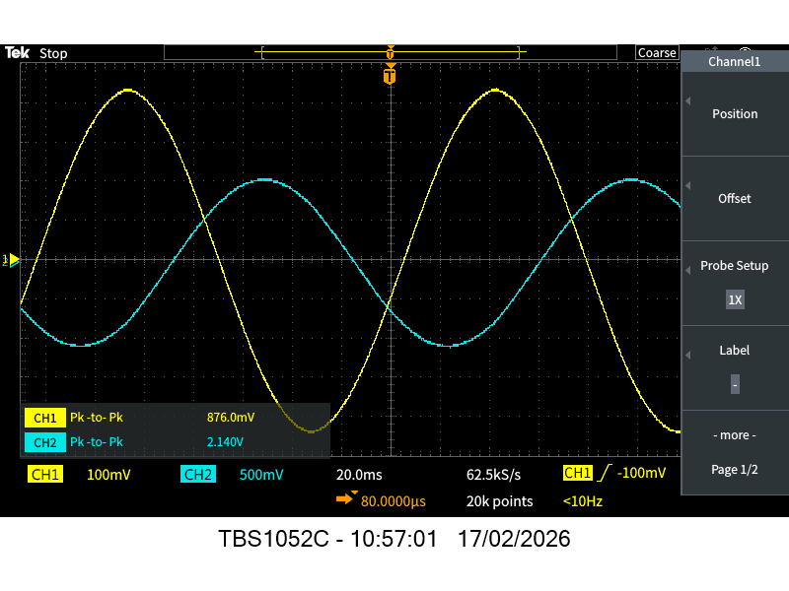
At upper cut off
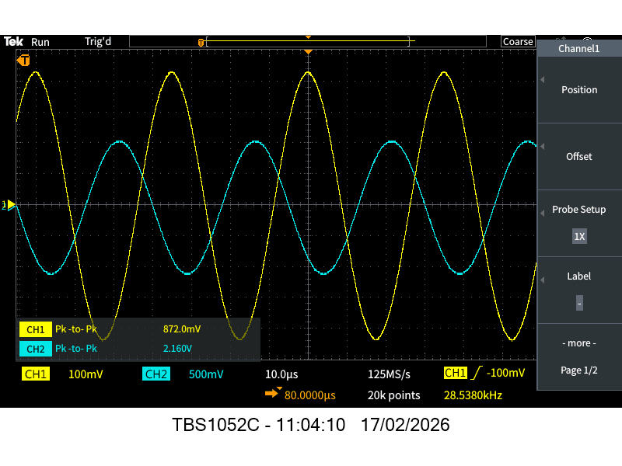

PCB – schematic final simulation at 440hz
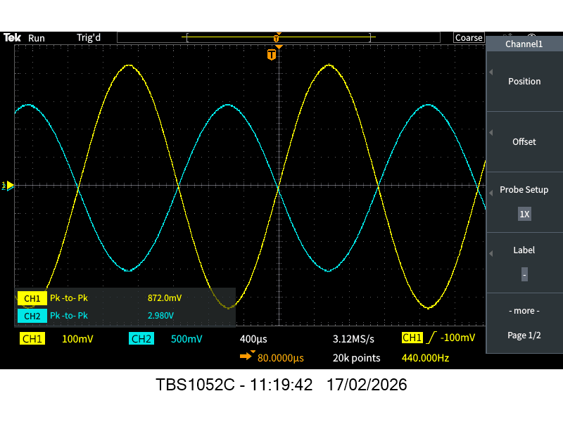

Any other notes??

Schedule overview
The weekly schedule will be provided on Blackboard.

Assessment

For the module, the following marks are allocated:
- Audio Amplifier report (70%)

This is a large project and you will need to keep on track rather than doing things at the last minute. You will be awarded marks for all of the items that you are required to submit and for the quality and craftsmanship of the end product (which you can keep once it has been marked).

The marks come from the report and the hardware that you submit. We will be looking for evidence of a well thought-out design process as well as test results and high-quality craftsmanship.

Audio Amplifier report (70%)
Since this is the first design report you have written at university I have provided a template report on Blackboard in the Learning Resources section (called ‘EEI1EL2_2025_26 - Audio Amplifier Report Template.docx’). The section descriptions and the figure captions give you a very clear indication on the requirements.

Please note all reports will be submitted to TurnItIn to be checked for plagiarism. There is a 15 page maximum limit on the length of the report. This includes the title, appendices and references.

It should be noted that the following things are not acceptable:
- Paying someone else to write your report.
- Copying or paraphrasing someone else’s report, designs, reference or results – whether they are in the same class or another year.

In addition, a high standard of English is expected. If it does not make sense it will not gain marks. For a detailed marking scheme, please refer to the marking rubric on Blackboard.

An excellent mark is achieved by including all information discussed in the report template and if the report has a high standard of English.

Further advice for completing a successful project
At the start of the project:
- Plan your work and give yourself plenty of time to overcome difficulties.
- Write down the information you think you need to know and a list of things of things you need to find out. Think about what part of the design process these things affect and therefore when you need to have the information by.
- Think about what information you will need for your report (Which results are important) before you start on the project work. Review this regularly – use the report template as an indication of this.

During the project:
- Make sure you know how everything will fit together before you layout your PCB – you should include mounting holes in the correct position and will need to think carefully about the best place to position connectors.
- Make extensive notes in your lab book as you progress.
- Save any simulation data and summarise what you have done/what it means at the time.
- Keep a record of the sources of information you look up and compile a complete list of references.

Towards the end:
- Check your notebook to confirm that you have all the necessary information.
- Leave time to edit your report.
- Check both spelling and grammar – proofread your report.

Further questions?
If you have further questions about the project and how it is running please email me i.phillips@aston.ac.uk

